UV / SUN SAFE POLICY

NATIONAL QUALITY STANDARD (NQS)
QUALITY AREA 2: CHILDREN’S HEALTH AND SAFETY
2.1 | Health | Each child’s health and physical activity is supported and promoted
2.1.1 | Wellbeing and comfort | Each child’s wellbeing and comfort is provided for, including appropriate opportunities to meet each child’s needs for sleep, rest and relaxation
2.1.3 | Healthy lifestyle | Healthy eating and physical activity are promoted and appropriate for each child
2.2 | Safety | Each child is protected
2.2.1 | Supervision | At all times, reasonable precautions and adequate supervision ensure children are protected from harm and hazard
QUALITY AREA 3: PHYSICAL ENVIRONMENT
3.1.1 | Fit for Purpose | Outdoor and indoor spaces, buildings, fixtures and fittings are suitable for their purpose, including supporting the access of every child

Aims
Our Sun Safe policy aims to protect all children and staff from the harmful effects of ultraviolet (UV) radiation from the sun and teach children good sun protection habits from an early age to reduce their risk. To ensure the outdoor environment provides shade for children, educators and staff to minimise unsafe UV exposure. Additionally, this policy provides guidance on how to protect children and staff from severe hot weather events which are becoming more prevalent in Australia resulting from climate change.

SCOPE & NEED FOR POLICY
This policy applies to children, families, staff, management, approved provider, nominated supervisor, students, volunteers and visitors of the Service.

The Education and Care Services National Regulations require policies and procedures to be in place in relation to sun protection. The vast majority of skin cancers are caused by over-exposure to UV radiation from the sun and Australia has one of the highest rates of skin cancer in the world.

Infants and toddlers aged up to four years of age are particularly vulnerable to UV damage, Damage at this young age is strongly associated with increased risk of skin cancer later in life. Good sun protection habits from an early age at early childhood can play a significant role in helping to reduce cancer risk.

We do note the importance of vitamin d as an essential nutrient and note many children in Australia have a vitamin d deficiency. Almost all our vitamin d comes from the sun’s radiation, and we only get a small amount of vitamin d from food.

When UV levels are above 3 most people get adequate UV levels by just spending a few minutes outdoors on most days of the week. In late autumn and winter when the UV index falls below 3 spending time outside with some skin uncovered.

Active outdoor play is encouraged throughout the day all year provided appropriate sun protection measures are used when necessary.

SUN SAFE STRATEGIES

MONITORING UV LEVELS
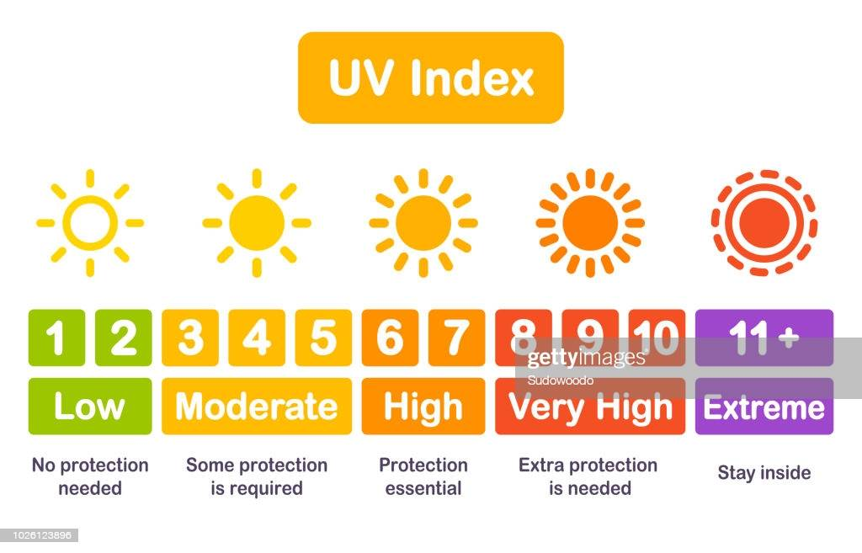

OUTDOOR ACTIVITIES
The sun protection measures listed are used for all outdoor activities during the daily local sun protection times, when the UV Index is 3 or above. At these levels, a combination of sun protection is recommended for all skin types.
Extra care is taken during peak UV radiation times and outdoor activities are scheduled outside of these times where possible.

The Service will use a combination of sun protection measures (see below) whenever UV Index levels reach 3 and above.

SHADE
THE APPROVED PROVIDER WILL ENSURE:
- sufficient natural, portable, or man-made shade is provided, particularly in high use areas.
- shaded areas will be used for play experiences and children will be encouraged to use available areas of shade.
- play experiences will be monitored throughout the day and moved as required to remain in the shade.
- regular risk assessments and reviews will be made of the outdoor area to assist in planning for further shade requirements.
- children who do not have appropriate hats or outdoor clothing are required to choose a shady play space or a suitable area protected from the sun and not move into unshaded areas of the playground.
- children will still be required to wear hats, protective clothing, and sunscreen when playing under natural or portable shade.

HATS
Educators, children, and visitors are required to wear sun safe hats at all times they are outdoors. Cancer
Council Australia describes sun safe hats as:
- hats that protect a person’s face, neck, and ears, which include:
  - a legionnaire hat – the front peak and flap should overlap at the sides and the flap should cover the neck.
  - a bucket hat with a deep crown and angled brim that is at least 5cm for young children and at least 6cm for adults and must shade the face, neck, and ears.
  - a broad brimmed hat with a brim size of at least 6cm for children or 7.5cm for adults. The brim should provide shade for the whole face.
Please note: Baseball caps or visors do not provide enough sun protection and therefore are not recommended.
- Children without a sun safe hat will be required to play in an area protected from the sun. They may be provided with a spare hat by the Service if available.

CLOTHING
- When outdoors, staff and children will wear sun safe clothing that covers as much of the skin as possible. Cancer Council Australia recommends clothing that:
  - covers the shoulders, back and stomach.
  - is loose fitting such as loose-fitting shirts and dresses with sleeves and collars or covered neckline, or longer style skirts, shorts and trousers.
- Children who are not wearing sun safe clothing can be provided with spare clothing or will be required to play under shade or in an area protected from the sun or provided with spare clothing.
Please note: Midriff, crop or singlet tops do not provide enough sun protection and therefore are not recommended.

SUNSCREEN
As per Cancer Council Australia recommendations:
- staff and children will apply SPF30 or higher broad-spectrum water-resistant sunscreen 20 minutes before going outdoors and reapply every 2 hours or more frequently if washed or wiped off.
- permission to apply sunscreen is included in the Service enrolment form (see Enrolment Policy)
- where children have allergies or sensitivity to the sunscreen, parents are asked to provide an alternative sunscreen, or the child is encouraged to play in the shade. A record of any allergy must be provided in writing from the parent/guardian and recorded on the child’s enrolment record. Cancer Council Australia recommends usage tests before applying a new sunscreen.
- to help develop independent skills ready for school, children from three years of age are given opportunities to apply their own sunscreen under supervision of staff and are encouraged to do so.
- sunscreen is stored in a cool, dry place and the use-by-date monitored.
- June/July UV is mostly below 3 therefore sunscreen is not compulsory. Hats and beanies are must still be worn when outside.
- During Spring and Summer parents are asked to apply sunscreen prior to arriving at the Centre in the mornings so children are to partake in outdoor play when they arrive. Parents are to communicate with educators on arrival as to whether they have applied sunscreen to their child.

BABIES 12 MONTHS AND UNDER
The widespread use of sunscreen on babies under six months is not generally recommended as they have very sensitive skin which may be more likely to suffer a reaction.
Cancer Council recommends keeping babies under 12 months away from direct sunlight as much as possible when UV levels are 3 and above, as their skin is more sensitive than adults’. Daily activities to ensure the baby is well protected from the sun and aim to minimize time outside during the middle of the day during the summer period when UV levels are strongest. When this is not possible, ensure that babies are protected from the sun by shade, protective clothing and a hat. Check the baby’s clothing, hat and shade positioning regularly to ensure he/she continues to be well protected from UV.

RISKS OF SUMMER PLAY
Australia has a hot climate and inevitably playground equipment and surfacing can heat up rapidly and retain heat. Many playground surfaces and equipment can exceed temperatures greater than 50°C and if young children come into contact with these surfaces, they can be burned severely within seconds. Surfaces can retain heat for long periods of time and cause burns to children.

Play surfaces must be monitored before children have access to the outdoor environment. Throughout summer educators will test play equipment by touch as part of the outdoor safety checklist before allowing any children to play on it. Educators will also encourage children to keep their shoes on during hot weather as the pavement becomes very hot during this time.

SEVERE HEAT
Severe heat or heatwaves are periods of unusually hot weather. Babies and young children can dehydrate quickly which can cause heat-related illness including heat stroke and heat exhaustion.

Active heatwave warnings are indicated within the Australian Warning System (AWS) and range from Advice to Emergency Warning. Risk management measures must be implemented and managed to ensure children remain safe and healthy during a severe heat event.

When the hot weather is extreme children will remain inside at playtime.

THE APPROVED PROVIDER/ NOMINATED SUPERVISOR AND EDUCATORS WILL:
- ensure obligations under the Education and Care National Law and Regulations are met.
- ensure risk assessments are conducted to identify any potential hazards to children during summer months that could cause harm or injury to children. Risk minimisation control measures will be put in place to protect children. Potential hazards could include:
  - hot equipment- slides, poles, guardrails, any metal surfaces
  - hot surfaces- rubber and synthetic grass, walkways, concrete surfaces
  - sun burn and dehydration.
  - access to bodies of water (filled water troughs/containers/trays/pools)
  - severe heat
  - bushfires and air pollution
- complete a Daily Playground Surface Temperature Check during summer months or extreme hot weather.
- use a thermometer or their hand to test surface temperature and make an informed decision about permitting children to play on equipment or in the outdoor space. If the surface temperature is determined to be too hot or is recorded as at or above 50°C it is recommended by Kid safe Australia that children do NOT play on the surface
- ensure children wear shoes when playing in the outdoor area- [children may remove shoes when playing in on grass, sand or mud pit]
- monitor the Bureau of Meteorology (BOM) for severe weather warnings and implement procedures to ensure the health and safety of all children and staff
- monitor bush fire activity and be aware of air quality and hazardous levels of air pollution caused by bushfires (see Bushfire Policy)
- ensure children have access to water at all times throughout the day and offer extra feeds/drinks to babies during hot weather to avoid dehydration.
- be aware of the signs and symptoms of heat-related illness in babies and young children and implement first aid as required.
- keep children indoors during severe heat events.
- ensure fans/air conditioning are used to help keep children cool.
- close blinds/curtains where required to prevent sun shining into rooms.
- adhere to NSWhealth department advice for hot weather risks and recommendations.

ROLE MODELLING AND WORK HEALTH AND SAFETY
Cancer Council Australia acknowledges that children are more likely to develop sun-safe habits if they are role-modelled and demonstrated by adults around them. Occupational UV exposure is also a WH&S issue. All educators, staff at the Service will therefore be required to role model appropriate sun protection behaviours by:
- wearing a sun safe hat (see Hats)
- wearing sun safe clothing (see Clothing)
- applying SPF30+ broad-spectrum water-resistant sunscreen 20 minutes before going outdoors
- using and promoting shade
- wearing sunglasses that meet the Australian Standard 1067:2003 (optional)
- discussing sun protection with children and demonstrating a positive and proactive approach to the management of sun protection in the Service
- regularly drinking water and encouraging children to drink extra water in hot weather.
- adapting the learning environment when severe weather events occur
- families and visitors are encouraged to role model positive sun safe behaviour.
- monitoring the UV Index Levels and Daily Sun Protection times throughout the day
- regularly monitoring and reviewing the effectiveness of the Sun Safety Policy
- submitting the Sun Safety Policy to the Cancer Council every three years to maintain SunSmart status (required if a SunSmart member).

EDUCATION AND INFORMATION
- Sun protection will be incorporated regularly into learning programs.
- Sun protection information will be promoted to staff, families and visitors.
- Severe hot weather events will be monitored through the Bureau of Meteorology and risk mitigation measures implemented
- Educators and staff are encouraged to complete free Cancer Council Generation SunSmart online PL learning modules.
- Further information and resources are available from the Cancer Council website and each state and territory SunSmart web page. See: https://www.cancer.org.au/cancer-information/causes-and-prevention/sun-safety
- See https://www.cancer.org.au/cancer-information/causes-and-prevention/sun-safety/be-sunsmart/sunsmart-in-schools for links.
- The Sun Safety Policy will be made available to all educators, staff, students, families, volunteers and visitors of the Service to ensure a comprehensive understanding about keeping sun safe including appropriate hat, clothing and sunscreen requirements.
- When enrolling their child/ren to our Service, parents will be required to give permission for educators to apply sunscreen to their child.
- Information about Sun Safety will be included in our Family Handbook and sun protection information and resources made accessible and communicated regularly to families.

CONTINUOUS IMPROVEMENT/REFLECTION
Our Sun Safe Policy will be updated and reviewed annually in consultation with families, staff, educators and management.

SOURCES

Australian Children’s Education & Care Quality Authority. (2021). Sun Protection- Policy Guidelines
Australian Children’s Education & Care Quality Authority. (2023). Guide to the National Quality Framework.
Australian Government Department of Education. Belonging, Being and Becoming: The Early Years Learning Framework for Australia.V2.0, 2022
Australian Government. Bureau of Meteorology. Home page (for UV Index): http://www.bom.gov.au/uv/
Australian Government. Bureau of Meteorology. Severe Weather Warning Services.
Cancer Council Australia. Be SunSmart. https://www.cancer.org.au/cancer-information/causes-and-prevention/sun-safety/be-sunsmart
Cancer Council. Home page: https://www.cancer.org.au/
Cancer Council. Preventing cancer: Sun protections. https://www.cancer.org.au/cancer-information/causes-and-prevention/sun-safety
Children's Services Act 1996
Cancer Council. SunSmart programs http://www.sunsmartnsw.com.au/about/
Early Childhood Australia Code of Ethics. (2016).
Education and Care Services National Law Act 2010. (Amended 2023).
Education and Care Services National Regulations. (Amended 2023)
Kidsafe NSW. How Hot is Too Hot to Play?
NSW Government. Department of health. (2023). Babies and young children in hot weather
Occupational Health and Safety Act 2004
Revised National Quality Standard. (2020).
Safe Work Australia: Guide on exposure to solar ultraviolet radiation (UVR) (2019).
Western Australian Education and Care Services National Regulations

POLICY REVIEWED BY | Sarah Kilby
POLICY REVIEWED | February 2024 | NEXT REVIEW DATE |  | February 2025

