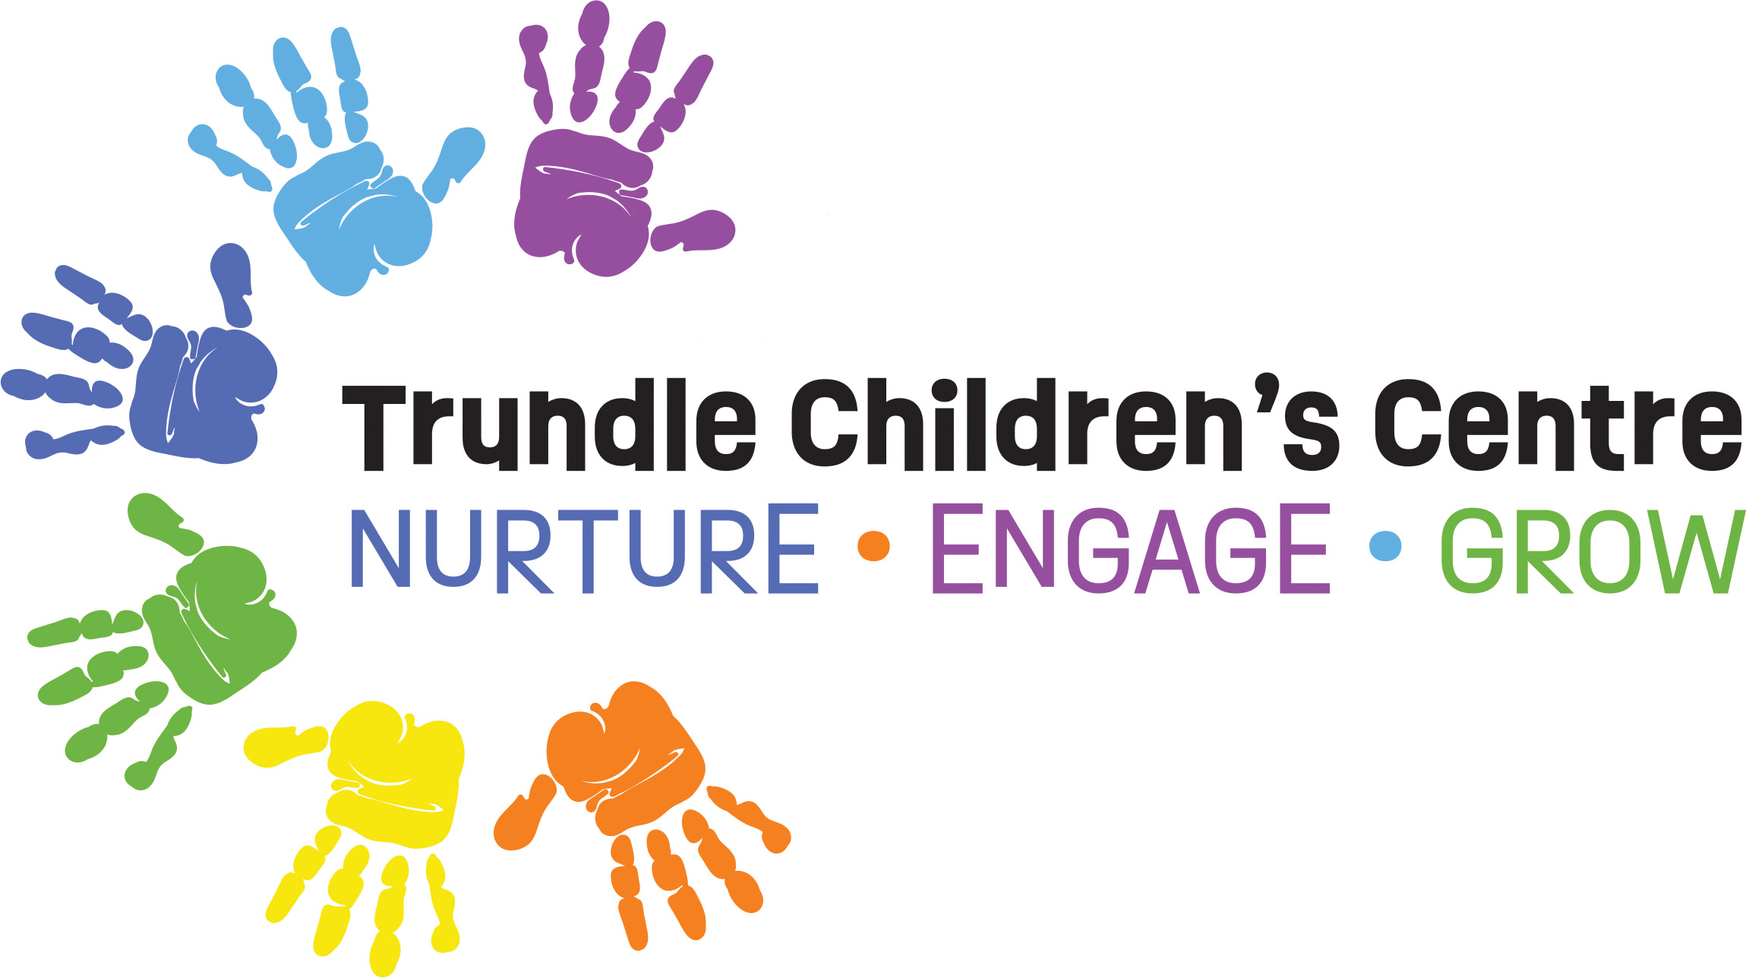

SICK CHILDREN POLICY
Children come into contact with many other children and adults in the early childhood environment increasing their exposure to others who may be sick or carrying an infectious illness. The National Quality Standard requires early childhood education and care services to implement specific strategies to minimise the spread of infectious illness and maintain a healthy environment for all children, educators and families.

We encourage parents and carers when assessing if their child is should attend childcare to ask themselves:
- Is my child well enough to comfortably take part in the day’s activities?
- Will my child pass on their illness to other children or staff?
- Will my child’s carer be able to care for my child without it impacting their ability to care for other children?
- Have you needed to give your child medication such as Panadol or Nurofen before attending the centre?
- If I felt like this, would I go to work?

NATIONAL QUALITY STANDARD (NQS)
QUALITY AREA 2: CHILDREN’S HEALTH AND SAFETY
2.1 | Health | Each child’s health and physical activity is supported and promoted.
2.1.1 | Wellbeing and comfort | Each child’s wellbeing and comfort is provided for, including appropriate opportunities to meet each child’s needs for sleep, rest and relaxation.
2.1.2 | Health practices and procedures | Effective illness and injury management and hygiene practices are promoted and implemented.

CHILDREN ARRIVING AT THE SERVICE WHO ARE UNWELL
Staff will not accept a child into care if they:
- have a contagious illness or infectious disease
- are unwell and unable to participate in normal activities or require additional attention
- have had a temperature and/or have been vomiting in the last 24 hours- as reported by a parent
- have had diarrhea in the last 48 hours
- have started a course of anti-biotics in the last 24 hours
- have been given medication (Panadol, nurofen etc) prior to arriving at the Service (with the exception of medication for teething relief). It is the responsibility of the parent/carer to notify a staff member if the child has been given medicine prior to arrival. Failure to communicate this to staff has led to serious illness and death in some centres.
- Present with a green runny nose
- Have a croup like cough
- Are clearly/visibly unwell

CHILDREN WHO BECOME ILL AT THE SERVICE
Children may become unwell throughout the day, in which case management and educators will respond to children’s individual symptoms of illness and provide immediate comfort and care.
- Educators will closely monitor and document the child’s symptoms
- Children who are unwell at the Service will be able to rest in a supervised area away from other children until parents or the emergency contact person is able to collect them
- A child who has passed runny stools or vomited whilst at the centre will be sent home and may only return once 48 hours after diarrhea or vomiting has stopped
- Educators will take the child’s temperature. If the child’s temperature is above 38°C or higher staff will contact the child’s parents/guardian/emergency contacts as soon as possible to have the child collected
- Educators will monitor the child closely and be alerted to vomiting, coughing or convulsions
- Educators will attempt to lower the child’s temperature by:
- removing excessive clothing (shoes, socks, jumper, pants)
- encouraging the child to take small sips of water
- moving the child to a quiet area where they can rest whilst being supervised
- Educators will check that written parental permission to administer paracetamol or ibuprofen has been provided during enrolment and filed in the child’s individual record
- Educators will check the medical history of the child to ensure there are no allergies before administering Panadol or Nurofen
- Accurate records will be kept of the child’s temperature, time taken, medication administered, dosage, staff member’s full name and name of staff member who witnessed the administration of medication (if relevant)
- Educators will continue to document any progressing symptoms
- Educators will thoroughly clean and disinfect any toys, resources or equipment that may be contaminated by a sick child.

REPORTING OUTBREAKS TO THE PUBLIC HEALTH UNIT
Management is required to notify the local Public Health Unit (PHU) by phone (call 1300 066 055) as soon as possible after they are made aware that a child enrolled at the Service is suffering from one of the following vaccine preventable diseases or outbreak of gastroenteritis.

- Diphtheria
- Mumps
- Poliomyelitis
- Haemophilus influenzae Type b (Hib)
- Meningococcal disease
- Rubella (‘German measles’)​
- Measles ​
- Pertussis (‘whooping cough’​)
- Tetanus ​

Notification is also required for:
An outbreak of 2 or more people with gastrointestinal or respiratory illness.

The Approved Provider must ensure notification is lodged through the NQA-ITS of an outbreak of COVID-19 when there are 5 cases or more within a 7-day period

Management will closely monitor health alerts and guidelines from Public Health Units and the Australian Government- Department of Health for any advice and emergency health management in the event of a contagious illness outbreak.

EXCLUDING CHILDREN FROM THE SERVICE
When a child has been diagnosed with an illness or infectious disease, the Service will refer to information about recommended exclusion periods from the Public Health Unit (PHU) and Staying healthy: Preventing infectious diseases in early childhood education and care services.
- When an infectious disease has been diagnosed, the Service will display appropriate documentation and alerts for families including information on the illness/disease, symptoms, infectious period and the exclusion period.
- Children that have had diarrhoea and vomiting will be asked to stay away from the Service for 48 hours after symptoms have ceased to reduce infection transmission as symptoms can develop again after 24 hours in many instances
- Children who have COVID-19 symptoms (fever, cough, sore throat, shortness of breath) may be requested to self-test using a rapid antigen test RAT.

NOTIFYING FAMILIES AND EMERGENCY CONTACT
- It is a requirement of the Service that all parents/carers and emergency contacts are able to pick up an ill child withing a 30-60 minute timeframe where possible. If this timeframe is unable to be met, then an appropriate timeframe as approved by the nominated supervisor/educator.
- In the event that the ill child is not collected in a timely manner, or should parents refuse to collect the child, a warning letter will be sent to the families outlining Service policies and requirements. The letter of warning will specify that if there is a future breach of this nature, the child’s position may be terminated.

MANAGEMENT AND EDUCATORS WILL ENSURE
- Effective hygiene policies and procedures are adhered to at all times to prevent the spread of illnesses
- they promote effective hand hygiene and cough etiquette
- effective environmental cleaning policies and procedures are adhered to all times
- all families are provided access to relevant policies upon enrolment
- that any child who registers a temperature above 38°C is collected from the Service. Children will not be permitted to return to the Service if they still have a temperature above 38°C the following day.
- families of a child with complex and chronic medical conditions will be notified in the event of an outbreak of an illness or infectious disease that could compromise their health
- families are notified to collect their child if they have vomited or had diarrhoea whilst at the Service.
- If a child has been sent home from the Centre, they will be unable to attend the next day as a minimum or until better.
THE APPROVED PROVIDER OR NOMINATED SUPERVISOR WILL ENSURE
- notification is made to the Regulatory Authorities within 24 hours of any incident involving serious injury or trauma to, or illness of, a child while being educated and cared for by an Education and Care Service, which:
(i) a reasonable person would consider required urgent medical attention from a registered medical practitioner or
(ii) for which the child attended, or ought reasonably to have attended, a hospital. For example: whooping cough, broken limb and anaphylaxis reaction
- any incident or emergency where the attendance of emergency services at the Education and Care Service premises was sought, or ought reasonably to have been sought (e.g.: severe asthma attack, seizure or anaphylaxis)
- parents or guardians are notified as soon as practicable and no later than 24 hours of the illness, accident, or trauma occurring

PARENT/FAMILY RESPONSIBILITY
In order to prevent the spread of disease, families are required to monitor their child’s health and not allow them to attend childcare if they have an infectious illness or display symptoms of an illness. Families may be asked to obtain a RAT test if their child is symptomatic for COVID-19.

Signs of illness in young children may include:
- runny, green nasal discharge
- high temperature
- diarrhoea
- red, swollen or discharging eyes (bacterial conjunctivitis)
- vomiting
- rashes (red/purple)
- irritability, unusually tired or lethargic
- drowsiness
- poor circulation
- poor feeding
- poor urine output
- a stiff neck or sensitivity to light
- pain
- mouth sores that cause drooling
- impetigo

Families are required to keep up to date with their child’s immunisation, providing a copy of the updated AIR Immunisation History Statement to the Service following each immunisation on the National Immunisation Schedule.

RETURNING TO CARE AFTER SURGERY
Children who have undergone any type of surgery will need to take advice from their doctor/surgeon as to when it is appropriate and safe to return to childcare.

A medical clearance statement will be required to ensure the child is fit and able to return to the Service and participate in daily activities.

Review
Policy Review Date
May 2023 by Sarah Kilby
Policy Due for Review
May 2024

